

**Insert Organisation Name Here**

**Annual Report**

**Insert Date Here YYYY/YY**



|  |
| --- |
|  |

|  |  |
| --- | --- |
| **Organisation** |  |
| **Document Purpose** | Guidance |
| **Title** | Annual Report |
| **Author** |  |
| **Date and Version** |  |
| **Linkages** | *Click here to add* Titles of linked documents |
| **To be read in conjunction with/ associated documents** | *Click here to add* titles of associated local documents |
| **Circulation** | All organisations within the Cheshire and Merseyside Major Trauma Network, Specialist Clinical Networks, Alder Hey Children’s Hospital, Liverpool Heart and Chest Hospital, Cheshire and Merseyside Rehabilitation Network, Northwest Ambulance Service (NWAS), Cheshire & Merseyside Integrated Care Board, NHS England. |
| **Description** | This document provides an overview of the development of *Click here to insert Organisation name* for the period *Click here to insert date range* |
| **Points of Contact** | *Click here to insert contact names and email addresses* |

**Contents** *Click on table below to update as required – click here to delete this statement*

1.0 Introduction 4

2.0 Context of Annual Report 4

3.0 Quality Surveillance: Update of Recommendations from Previous Peer Review 4

4.0 Summary of Activity and Achievements 5

4.1 Activity/NMTR Data 5

4.2 Achievements: Reception and Resuscitation 6

4.3 Achievements: Definitive Care 7

4.4 Achievements: Rehabilitation 7

5.0 Governance 7

6.0 Patient Experience and Outcomes 7

7.0 Education and Training / Sharing Practice 8

8.0 Current challeges and pressures 8

9.0 Key Priorities for the Future 8

9.0 Summary 9

# 1.0 Introduction

*Click here* to provide a brief introduction to your annual report. This should include an overview of your organisation, it’s function as a Trauma Unit/MTCC within the Cheshire & Mersey Major Trauma Specialist Clinical Network along with interface with other organisations.

# 2.0 Context of Annual Report

*(Suggested Content – Click here to delete this statement)*

As part of the Cheshire & Mersey Major Trauma Specialist Clinical Network Peer Review Programme, *Insert Organistaion Name Here* completed the required self-assessment process in *Insert date here*. This was followed up with a service review visit on the *Insert date here* undertaken by the by the Cheshire and Mersey Major Trauma Specialist Clinical Network (CSN). The CSN review also included assessment against the National and CMMTN Clinical Standards. Following this, formal confirmation dated *Insert date here* was provided confirming that *Insert Organisation Name*  *Delete as required:* had / had not demonstrated compliance to the required standard to maintain accreditation as *Delete as required* an MTCC/ a TU.

This report will summarise the key outputs and findings from the self-assessment and accreditation review process.

# 3.0 Quality Surveillance: Update of Recommendations from Previous Peer Review

*Click here* – Based on previous peer review feedback, please use this space to provide an update on recommendations.

|  |  |
| --- | --- |
| **ODN Recommendations** | **Update Against Action Plan** |
|  |  |
|  |  |
|  |  |

# 4.0 Summary of Activity and Achievements

## 4.1 Activity/National Major Trauma Registry (NMTR) Data

*Click here* In the absence of TARN/NMTR data, please use this part to provide any Major Trauma related data that has been collated locally over the period covered by the annual report.

Suggested areas to include number of Trauma Team Activations, MOI, injuries sustained, estimated ISS profile, transfers, etc.

Once reporting via the National Major Trauma Registry becomes available, key data should be provided in this section.

Suggested areas of focus are provided below:

NMTR data completeness and data accreditation for *Insert date here (YYYY)* as published on NMTR website is outlined in table 1.

Table 1

|  |  |  |
| --- | --- | --- |
| Site | Data Completeness | Data Accreditation |
|  |  |  |

Other additional key data is summarised below within four categories.

* Probability of survival (W’s scores)
* Major Trauma Dashboards
* Trauma Team Activations
* Overall activity by ISS

**4.11 Rates of Survival (W’s Scores)**

*Click here to* Provide brief overview of W’s Scores and when available provide chart below in figure 1 *(Example provided which will need replacing with own organisations graph once available)*

Figure 1

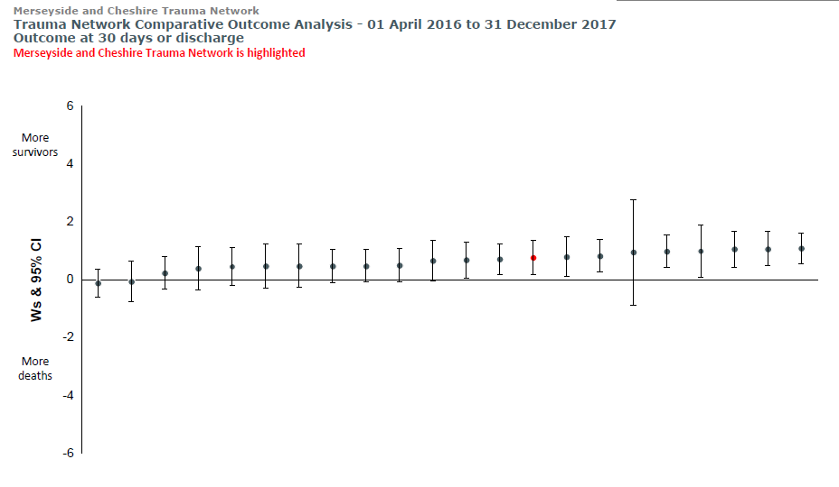

**4.12 Major Trauma Dashboards**

*Click here* to provide key data from your most recent Major Trauma Dashboard

**4.13 Trauma Team Activations**

*Click here* to provide most recent data relating to Trauma Team Activations covering the previous 12-month period – this can be in graph format with additional brief narrative.

**4.14 Overall Activity by ISS**

*Click here* to provide most recent data relating to Overall Activity by ISS covering the previous 12-month period – this can be in graph format with additional brief narrative

## 4.2 Achievements: Reception and Resuscitation

A summary of the achievements as related to the reception and resuscitation aspect of the patient pathway are summarised below.

* *Click here* to add brief overview of achievements relating to reception and resuscitation in this section. For example, this can include improvements to estates and facilities within ED, procurement of equipment, implementation of HALO trolly, development of policies and pathways, access to CT etc.

## 4.3 Achievements: Definitive Care

A summary of the achievements as related to the definitive care aspect of the patient pathway are summarised below.

* *Click here* to add brief overview of achievmnets realating to definitive care for major trauma patinets within your organisation. For example this could include the development and implementation of clinical guidelines, improved interface with speciality teams,

## 4.4 Achievements: Rehabilitation

A summary of the achievements as related to the rehabilitation aspect of the patient pathway are summarised below.

* *Click here* to add brief overview of achievmnets realating to rehabilitation for major trauma patinets within your organisation. For example this could include the development and implementation of Rehab Prescription or Checklist, appointmnet of Rehab Coordintaor/Lead AHP, membership and engagemnet in Network sub-groups etc.

# 5.0 Governance

Overall network governance is provided by the infrastructure of the SCN. The *Click here* to change as required MTCC / TU feeds in to this through representation at the Cheshire & Mersey Major Trauma Network Clinical Group Meeting.

*Click here* to provide detail of local Governance structure for Major Trauma within your organisation. This should include brief description of Major Trauma Working Group (membership, and reporting structure and meetings held over the previous 12-month period covered by the Annual Report etc.)

Provide overview of Mortality Review process and local data

Provide an overview of internal DATIX relating to major trauma, common themes

Provide an overview of incidents submitted or responded to, via the Network

# 6.0 Patient Experience and Outcomes

**Patient Experience and Information**

*Click here* to provide any updates or data on key achievements relating top patient experience and outcomes. For example, this could include the implementation of patient advice leaflets, PROMS, Friends and Family Test responses or any innovations implemented to improve patient experience/information

# 7.0 Education and Training / Sharing Practice

**Education and Training**

In addition to routine training and development undertaken across the MTCC/TU delete as appropriate the following are a few highlights of initiatives that have taken place during the past twelve months.

* *Click here* to provide highlights

*Click here* to provide contemporaneous data relating to ED Level 1 & Level 2 NMTNG Competency Framework Compliance and Ward Competencies as appropriate and reference any forecasted changes.

*Click here* to provide an overview of Medical Training relating to medical staff involved in Major Trauma – this can include TTL training logs ETC/ATLS/APLS compliance, DCS and DCOTS training etc.

*Click here* to provide an overview of Major Trauma Simulation programme that has taken place over the 12-month period covered by the Annual Report

**Audit and Research, Conferences and Publications**

*Click here* to provide an overview of any National Clinical Trials, Network & local audits, presentations, and publications relating to Major Trauma from your organisation

# 8.0 Current challenges and pressures

*Click here* to provide an overview of the current challenges and pressures within your organisation

# 9.0 Key Priorities for the Future

*Click here* to provide brief narrative around key priorties for the YYYY/YY period

Key priorties are summarised below and form the basis of the work plan for *YYYY/YY*;

|  |
| --- |
| **Priority Area: Reporting and Performance Monitoring** |
|  |
| **Priority Area: Human Resource Infrastructure** |
|  |
| **Priority Area: Estates and Facilities** |
|  |
| **Priority Area: Clinical Pathways** |
|  |
| **Priority Area: Patient Experience** |
|  |
| **Priority Area: Clinical Governance** |
|  |
| **Priority Area: Strategic Initiatives** |
|  |

# 9.0 Summary

*Click here* to provide a summary of you Annual Report